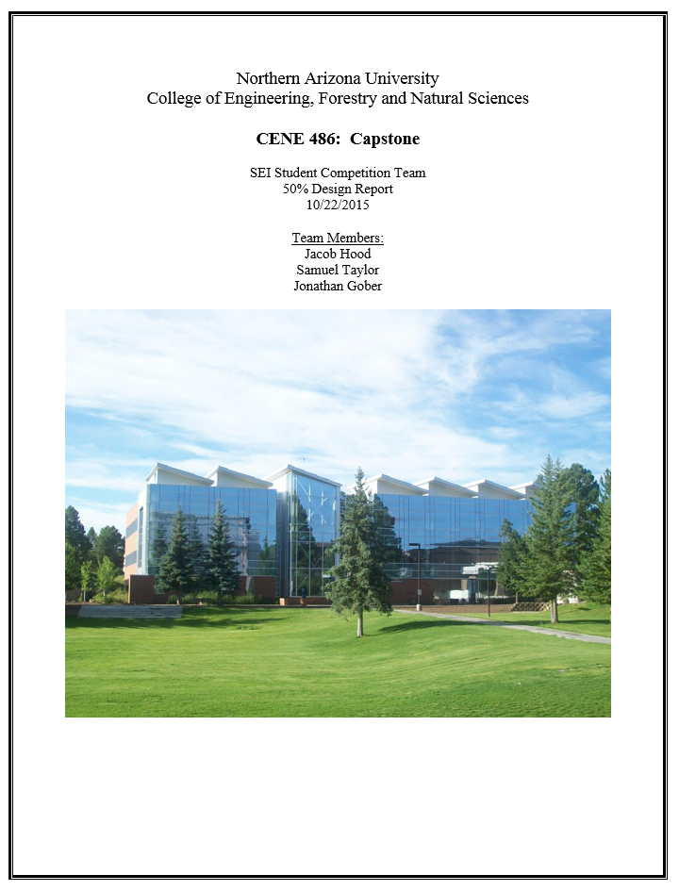

Table of Contents

Acknowledgements 0

1.0 Project Description 1

2.0 Background 2

3.0 Design Alternatives 3

4.0 Preliminary Schematic Design 5

4.1 Floor Plan 6

4.2 Design Loads 7

4.2.1 Live Loads 7

4.2.2 Dead Loads 7

4.2.3 Snow Loads 7

4.2.4 Seismic Loads 7

4.2.5 Wind Loads 8

4.3 Structural Members 10

4.3.1 Floor Slabs 10

4.3.2 Girders/Beams 11

4.3.3 Columns 12

4.3.4 Basic Connections 13

4.3.5 Cross Bracing 13

4.3.6 Shear Walls 13

5.0 References 14

6.0 Appendices 15

Appendix 6.1: Flagstaff Main Campus 15

Appendix 6.2: Live load Reduction 16

Appendix 6.3: Floor Slab 17

Appendix 6.4: Girders, Beams and Spandrels 18

Appendix 6.5: Columns 19

# Acknowledgements

Like all great projects, this project would not be possible without the unconditional support and assistance from non-project members. We would like to personally extend our gratitude to the following individuals who have made this report possible and have provided unwavering support throughout our design process:

Dr. Robin Tuchscherer, PE, SE, and Northern Arizona University Assistant Professor, for providing technical advice and moral support.

Dr. Wilbert Odem, PE, Northern Arizona University Professor, for providing professional advice and technical guidance.

Dr. Charles Schlinger, PE, Northern Arizona University Professor (Emeritus), for providing professional advice and technical guidance.

Mark Lamer, PE, Northern Arizona University Lecturer, our client, for helping us establish our project requirements.

The family and friends of the team members for their continued moral, emotional, and financial support.

# Project Description

The purpose of this project is to submit a structural design report to the Structural Engineering Institute’s (SEI) student design competition while addressing the current population issue facing Northern Arizona University’s (NAU) School of Engineering. The current engineering building is at 98 percent capacity but despite this concern, the School of Engineering is predicted to double in size within the next five years [1]. This presents a unique opportunity for structural design that can be addressed while competing in the SEI student competition and improving the engineering school’s nationwide recognition. The site is located on the south side of NAU’s main campus in Flagstaff, Arizona (Appendix 6.1), surrounded by NAU’s Forestry, Health Sciences, and Social and Behavioral Sciences buildings. The exact location of the project can be seen in Figure 1 below.

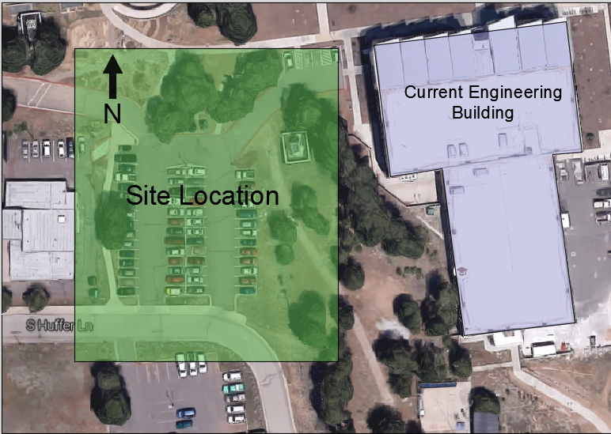

Figure 1: Site Location

Throughout the initial planning phases of the project it was determined that the structure to be designed will be an entirely new building and shall utilize various timber materials for its structural components. Following relevant building codes such as the International Building Code (IBC) [2], ASCE 7-10 [3], Allowable Stress Design (ASD) [5] and the Flagstaff Building Code [5] will complete this design.

# Background

In order to determine the necessary space requirements, the team met with their client, Mark Lamer, to discuss the expected increase in population. It was decided that due to the growth rate, the expected design and construction time of a new building, the total square footage of the addition should be 20 percent larger than the square footage of the existing building. The total square footage of the existing building was found to be 93,590 square feet (sf) in the existing engineering building plans and therefore the addition will have to be around 112,308 sf. The chairs of each engineering department were contacted to determine their personal requests for the new building, which ended up being around 31,540 square feet of requested space. The requests included: more offices, large lecture halls, research labs, faculty and grad student offices, SI study rooms, computer labs, and another internet café.

Aside from the space requirements, many of the design considerations have been centered on the SEI competition’s weighted requirements, which can be seen below [6].

* **Format** – choice of an appropriate format, suitable for presentation to a client (10%)
* **Material** - technical or theoretical content correctness (30%)
* **Demonstrated Knowledge and Understanding of Subject** - depth of knowledge (20%)
* **Originality and Complexity** - design and discussion innovation (20%)
* **Presentation** - neatness, style, organization, clarity and readability (20%)

The category that took precedence for the design was originality and complexity. The team decided that the design needed to be both innovative, but simple enough that three undergraduate students could complete it in a timely and detailed manner. The team’s technical advisor, Professor Robin Tuchscherer, suggested the idea of creating the proposed structure out of wood members. This is due to the fact that heavy timber commercial construction is often used in Europe and is becoming more common in America. Heavy timber presents benefits in sustainability as a renewable resource and its manufacturing process has a much smaller carbon emissions footprint. It also has benefits for construction because the members are prefabricated and therefore reduce the on-site construction time. The utilization of timber should satisfy the innovation portion of the project and allow the team to design a relatively simple floor plan.

# Design Alternatives

During the planning portion of the project, there were three design alternatives that were discussed, they are as follows:

1. **Build on Top of the Existing Building**

This plan focused primarily on the existing building and would require a detailed analysis of the existing building documents. These were acquired from NAU’s facility services. Plan one would also require a seamless integration between the addition and the existing building and would likely result in a six story building.

1. **Build on Top of the Existing Building and Out**

Plan two, like plan one, would largely focus on tying into the existing building and would also require detailed analysis of the existing plans. It would only expand the third floor to the rest of the building and then add extra space on either side of the building with a potential fourth floor.

1. **Build Entirely New Building**

This would involve building an entirely new building just next to the existing building that would not need to tie into the existing structure. However, the team would then have to come up with another way to make the design innovative and original.

The following decision matrix was then created to help pick the best option:

|  |  |  |  |  |
| --- | --- | --- | --- | --- |
| **Decision Matrix** | | | | |
|  | **Innovation** | **Design Requirements** | **Constructability** | **Total** |
| **Weight** | 25% | 50% | 25% |  |
| **Design 1: Build Up** | 9 | 5 | 5 | 6 |
| **Design 2: Build Up/Out** | 8 | 6 | 6 | 6.5 |
| **Design 3: Build New (Wood)** | 7 | 7 | 8 | 7.25 |

Table1: Simplified Decision Matrix

Deciding on the most feasible design made the final decision. The interaction between the proposed addition, the original building, and its addition in 2005 proved to be too daunting of a task. The most practical option then was to design an entirely new building using the innovative concept of a heavy timber commercial building.

# Preliminary Schematic Design

After the final design was decided upon, the schematic design phase could begin. The team utilized Google Sketch Up to brainstorm different building styles and get a feel for what the final product would look like. The second step was to choose the building dimensions and geometry to then place the column grid within the confines of the building dimensions. The third and most intensive step was to design all the necessary structural members by applying loads to the preliminary structure. The third step, currently a work in progress, dealt with defining the applied loads and is discussed in this section.

In order to keep the design innovative and original, it was decided that the team would use a combination of Glulam beams and columns, Cross-Laminated Timber (CLT) shear walls and Laminated Veneer Lumber (LVL) for a concrete composite floor slab. Figures 2-4 below provide general examples of how each of these structural members appear.

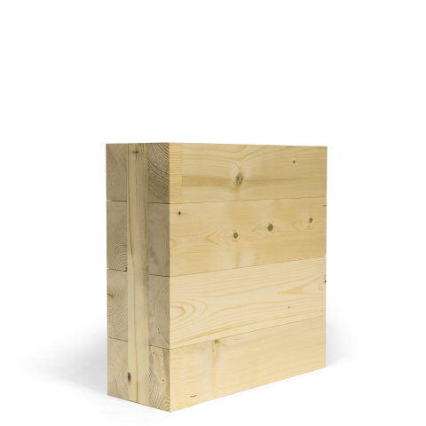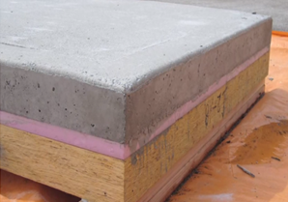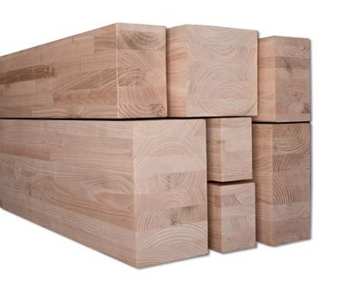

Figure 4: Typical LVL-Concrete composite floor slab, Source: naturallywood.com

Figure 2:

Figure 2: Various Glulam Beams, Source: www.globalwoodtrade.com

Figure 3:

Figure 3: Typical CLT section, Source: nordic.ca

Glulam beams are relatively normal in the US and their design processes can be found in the ASD [5]. CLT is becoming more common in the US and it has its own American version handbook but it is still not as common as Glulam beams. The LVL-Concrete composite floor slab, on the other hand, is not referenced in US codes and therefore must be designed primarily by using the transformed section method and designing for an allowable deflection.

## Floor Plan

Below, figure 5, is the most current general floor plan for the first through third floors of the new building. In order to accommodate the space requirements, a smaller fourth floor will be added. The green shade on the left part of the floor plan shows the size and location of the fourth floor. Currently, only the girders, spandrel beams, and columns are depicted in the floor plan. In the future, the LVL-Concrete composite floor panels will be shown as well. They will span from East to West and will rest on the North to South spanning girders. There will be a total of five staircases and one elevator to make for easier travel between floors. The column spacing and building dimensions can also be seen.

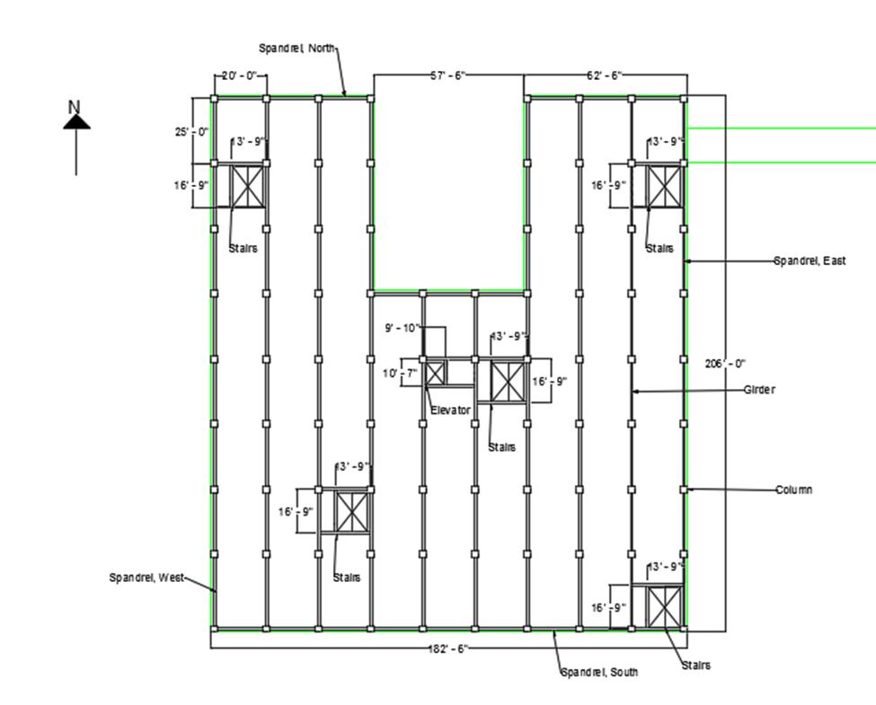

Figure 5: General floor plan

## Design Loads

The following loads have been calculated so that the team may begin the framing portion of the design process.

### **Live Loads**

The live load, which typically includes people, furniture, and walls, was found in ASCE 7-10 [3] table 4-1. From table 4-1 it was determined that the live load is equal to 80 pounds per square foot (psf). It is 80 psf because the building being designed is a school and 80 psf was the maximum value for floors two and above. Using the maximum live load for the whole building allows for the most flexible floor plan possible. There is also a live load reduction factor used for the girders, as well as the columns. The live load reduction can be seen in Appendix 6.2.

### **Dead Loads**

The dead load includes the weight of the structure and any immovable objects, such as mechanical equipment. The weight of the mechanical objects was assumed to be 15 psf. The floor load was found to be 68.75 psf including the mechanical equipment and the calculations for this can be found in Appendix C. The self-weight of the beams, girders, and spandrels vary and can be found in Appendix D.

### **Snow Loads**

The snow loads are based on the roof slope, shape, thermal properties, and a percentage of ground snow loads. Flagstaff City Code [5] was used to determine the snow load, which is equal to 40 psf.

### **Seismic Loads**

To determine the potential shear forces on a building due to seismic forces it is necessary to perform a seismic loading procedure. The shear forces due to seismic activity are then used to design a building’s shear wall system or cross bracing. The loading used for this procedure involved determining factors based on soil type, building material, height of building, site location, and building type.

The building type gives a building occupancy category factor ranging from I-IV, which was determined to be III - High Hazard Occupancy. This was due to its use as a university building based on ASCE 7 – 10 [3]. Next the location of the building was used to determine its’ seismic design category ranging from A-F. From USGS [7] the design category was found to be C. Next the surrounding soil types, also found from USGS [7], were used to determine the building’s site classification. The site classification was found to be D. Other seismic factors were calculated, using these classifications, from ASCE 7 – 10 [3]. These include the site coefficient adjustment factors, design ground motion parameters, basic ground motion parameters, and importance factors. These factors were then used in equation 1 to determine the seismic response coefficient.

Equation 1: $C_{s}= \frac{S_{DS}}{R/{I_{e}}}= \frac{0.36}{6/{1.25}}=0.075$ (Seismic Response Coefficient)

The seismic response coefficient was then used in equations 2 – 5 below to determine the shears on each respective level.

Equation 2: $V_{R}= C_{s}* W_{R};$ (Seismic Roof Shear) = $132,044 lb$

Equation 3: $V_{4}= C_{s}* {(W}_{R}+ W_{4})$; (Seismic Shear on fourth floor) = $345,846 lb$

Equation 4: $V_{3}= C_{s}* {(W}_{R}+ W_{4}+ W_{3})$; (Seismic Shear on third floor) = $559,648 lb$

Equation 5: $V_{B}= C_{s}*{(W}_{R}+ W_{4}+ W_{3}+ W_{2})$; (Seismic Base Shear) = $773,449 lb$

### **Wind Loads**

The wind loads are necessary for consideration of the lateral force resisting system. In order to calculate the applied wind loads, the simplified directional procedure in chapter 27 of ASCE 7-10 [3] was used. Like the seismic procedure, a number of factors had to first be found. These factors were: Risk category, basic wind speed, directionality factor, exposure category, topographic factor, gust effect factor, enclosure classification, and the velocity pressure exposure coefficient.

After all of these factors and classifications were determined and the seismic loads were calculated it was decided that the building could be modeled as an enclosed simple diaphragm. This allowed for a simplified directional procedure that required the mean building height and the length to width ratio of the building footprint. The length to width ratio is essentially 1 and the mean height was found to be around 49 feet and for calculation purposes a mean building height of 50 feet was used. ASCE 7-10 [3] has tables for the applied wind loads in chapter 27 part two that relate to the exposure class which was determined to be class C from the flagstaff city code [5] and the basic wind speed of 120 mph for a risk category III building in Arizona [3]. The maximum distributed load from this table was found to be 39.2 psf. This load was then applied to each floor and then summed at the base to find the total shear due to wind that the building must resist. The total shear at the base of the building was found to equal roughly 367.3 kips which is less than half of the base seismic shear as shown in the previous section. The following schematic visualizes the wind load application.

Elevation View

4th floor

3rd floor

H

Pu = 39.2psf = design load due to wind

2nd floor

1st floor

L

**Conclusion:**

V4 = V3 = V2 = 104,977 lb

VR = VB =52,488 lb

Where: V=Shear at each floor

## Structural Members

This section will include details on each of the structural components that will complete the structural plans for the new engineering building addition.

### **Floor Slabs**

The floor slab is a composite material, consisting of concrete, insulation and laminated veneer lumber, as seen in figure 6. In order to find the thickness for each material a base thickness of 4 inches was assumed. Then the moment of inertia (I) was calculated using the properties of each material. The weight of the material was found using the unit weight of each material and the live load was 80 psf. In order to verify that the thickness of each material was appropriate it was assumed that deflection was the governing factor. This was done using the equations 6-9 below:

Equation 6: $∆_{Allow, Dead} = \frac{L}{240}; L= Length$

Equation 7: $∆_{Allow, Dead+Live} = \frac{L}{360}$

Equation 8: $∆_{Max, Dead} = \frac{5\left(DL\right)L^{4}}{384IE}; E= Modulous of Elasticty, DL=Dead Load$

Equation 9: $∆_{Max,Live+Dead} = \frac{5\left(DL+LL\right)L^{4}}{384IE}; I= Moment of Inertia, LL= Live Load$

Where:

$∆_{Allow,Dead}= Allowable defelction for the dead load$

$$∆_{Allow,Dead+Live}= Allowable defelction for the dead and live load$$

All of the calculations for the floor slab can be found in Appendix 6.3. The final dimensions can be seen in figure 6 below.

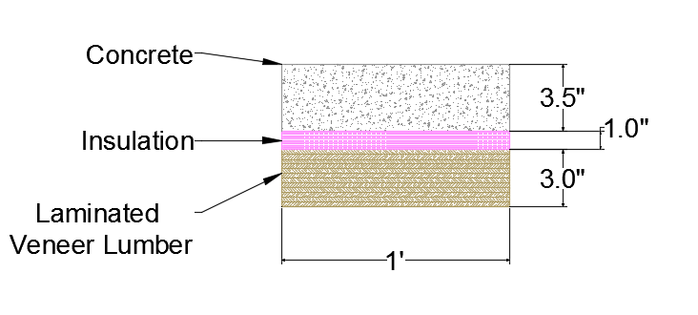

Figure 6: Floor Slab - Composite Material

### **Girders/Beams**

After determining the weight of the floor slab and mechanical units for the building, the dimensions for the girders and beams could be calculated. The material type and properties were found to be 24F – 1.8E, in the ASD [4], and the adjustment factors were found in the Structural Engineering Reference Manual (SERM) [8]. These adjustment factors, beam dimensions and material properties were used to determine whether or not the beam dimension were sufficient for bending, shear and deflection. The adjustment factors for the bending forces as found in the SERM [8] include factors due to load duration, wet service, beam stability, temperature, incising, size, repetitive member, flatwise, volume, and curvature. Once all of the factors were calculated and the allowable bending stress for the selected Glue Laminated Timber was found. The calculation for the bending stress can be seen in Appendix 6.4.

When designing the girders and beams for shear the factors, as listed in SERM [8], were load duration, wet service, temperature, and incising. Once these factors were determined, the same material was used to find the maximum shear force the timber could handle. The calculations for this can be seen in Appendix 6.4.

The last item that was addressed in order to verify the beam dimensions was to check for deflection. In order to do this, equations 6 – 9 were used again and the calculations can be seen in Appendix 6.4.

The calculated beam dimensions can be seen below in figure 7.

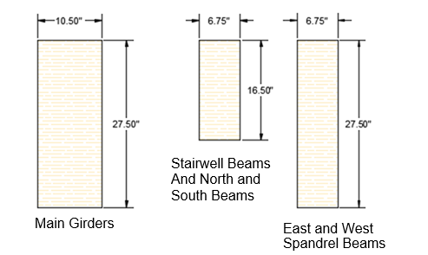

Figure 7: Beam Dimensions

### **Columns**

To determine the proper column sizes for the building, the weight on each column was found using the tributary areas and multiplying it by the live load plus the dead load. The process for determining column dimensions was very similar to that of designing the girders and beams and also required assuming preliminary dimensions. From these assumed dimensions the factors as listed by the SERM [8] for determining the allowable compressive force involved the factors due to load duration, wet service, buckling, temperature, and incising. Once these factors were determined, the properties of the selected Glue Laminated Timber was again used by multiplying the factors by the maximum compressive force of the timber. The calculations for this can be seen in Appendix 6.5.

The calculated column dimensions can be seen below in figure 8.

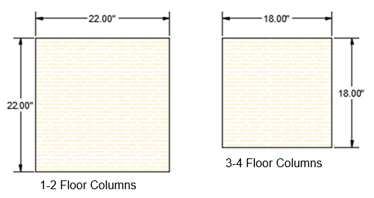

Figure 8: Column Dimensions

### **Basic Connections**

It is anticipated that basic steel timber connections will be used for the structural connections. After the structure has been modeled in Risa the team will then know how much shear each connection will need to resist and will be able to pick the best from there.

### **Cross Bracing**

Cross bracing may be implemented to resist laterally applied loads. The benefit of cross bracing over shear walls is that cross bracing allows for a more open building and more windows. In general, cross-bracing and shear walls are interchangeable and serve the same function. For the purposes of this project, steel tendons will likely be used as the cross bracing elements.

### **Shear Walls**

Like cross bracing, shear walls are designed to resist lateral loads and they may be interchanged with cross bracing for visual effects. Shear walls also likely weigh more than cross bracing, which may factor into the loads on the spandrel beams. It is anticipated that CLT will be used if shear walls are added to the design.

# References

[1] Staff, Engineering. Engineering Data Growth Predictions. 2014. Raw data. Northern Arizona University, Flagstaff.

[2] (COR), International Code Council. International Building Code, 2012. 1st ed. Vol. 1. Country Club Hills, IL: International Code Council, 2011. Print.

[3] Simiu, Emil. Design of Buildings for Wind a Practical Guide for ASCE 7-10 Standard Users and Designers of Special Structures. Hoboken: Wiley, 2011. Print.

[4] ASD: Allowable stress design: Manual for engineered wood construction (2001 ed.). (2001). Washington, DC (1111 19th St., NW, Suite 800, Washington 20036): AF & PA.

[5] City of Flagstaff 2011 amendments to Flagstaff City Code, Title 4, building code. (2011). Flagstaff, Ariz.: City of Flagstaff.

[6] ASCE, http://www.structurescongress.org/program/student-competition/, date accessed January 30, 2015

[7] Welcome to the USGS - U.S. Geological Survey. <http://www.usgs.gov/>, Retrieved October 20, 2015.

[8] Williams, A. (2001). Structural engineering reference manual. Belmont, CA: Professional Publications.

# Appendices

## Appendix 6.1: Flagstaff Main Campus

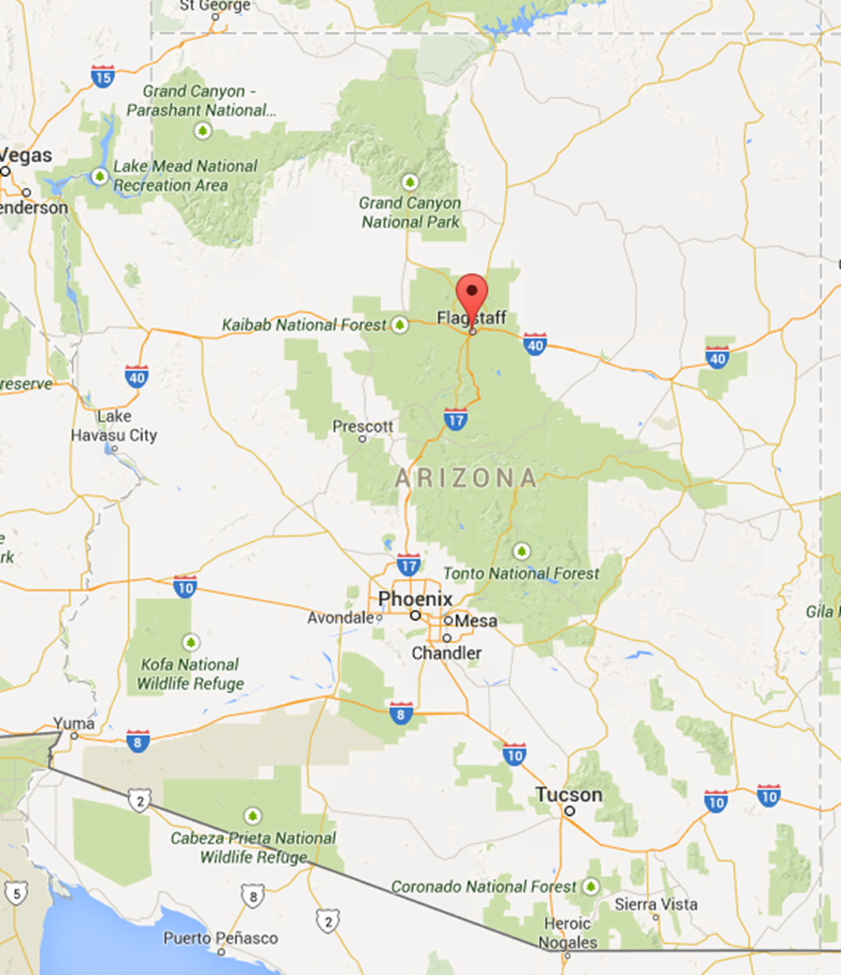

Figure A-1: Flagstaff, AZ

## Appendix 6.2: Live load Reduction

## Appendix 6.3: Floor Slab

## Appendix 6.4: Girders, Beams and Spandrels

## Appendix 6.5: Columns